EZCARDINFO.COM

You can enroll any of your cards on this site. Here you can view all your transactions and you can set up electronic payments to be paid one time or on a schedule. It is a secure site. You can also dispute charges on this site.

First you’ll have to register your card.

Then set up a user name and password.

You will also have to set up security questions.

Don’t forgot to write this information down!

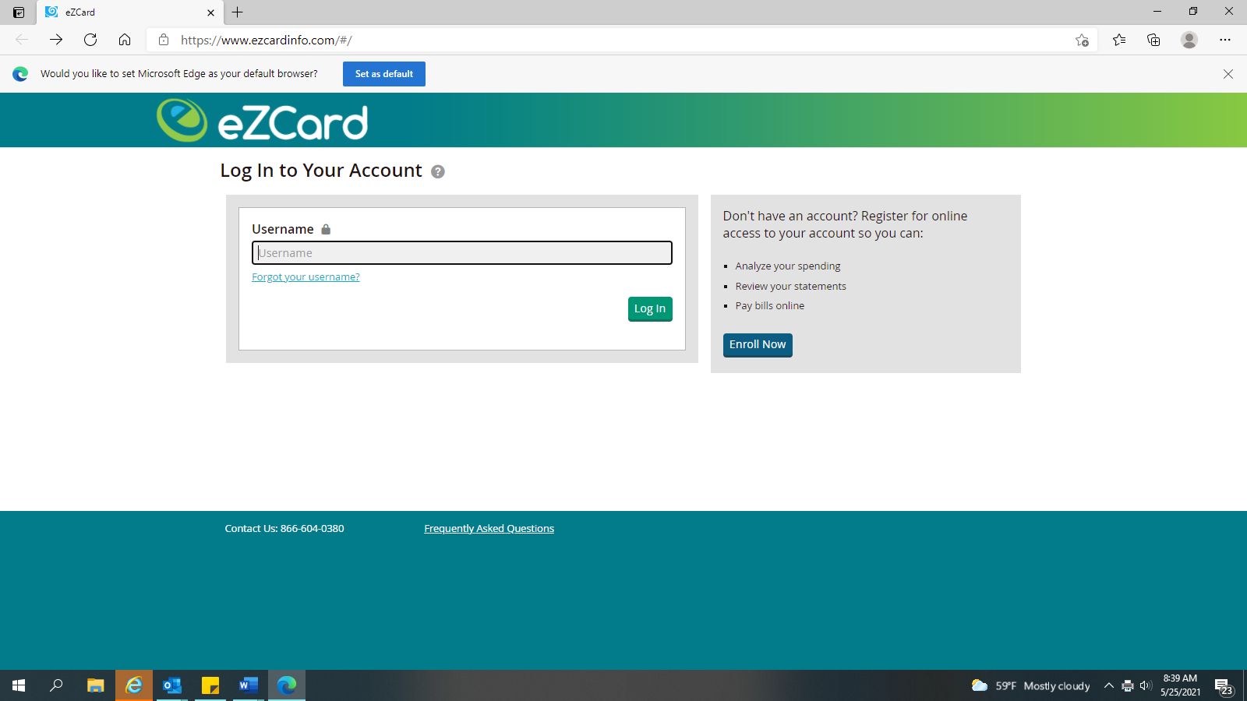

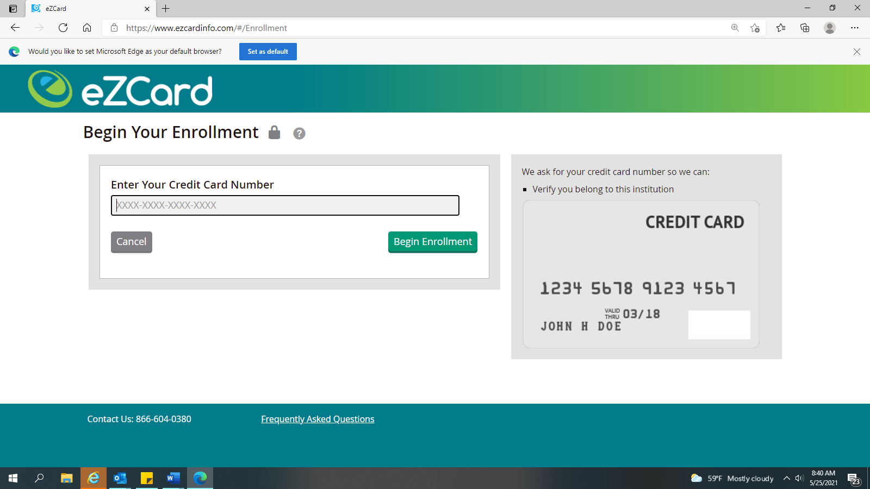

This is the first step: Register your card

Set up your user name and password

Set up your security questions

WRITE THE INFORMATION DOWN!!!

